**Module 8 Activity 2: Closing the last loophole HTTPS**

Saurabh Kale

IFT 458/554: Middleware Programming & Database Security

Dinesh Sthapit

November 30th, 2023

* **Generate the Private key**

Private key generated-

* **generate a self-signed SSL certificate**

On my PC it was not able to take full name of city, state, etc. Just two characters were accepting as shown below-

So did by running following command-

* **Generated Server.cert-**

* **Verify the files were generated correctly-**

**Certification-**

**Key-**

**Code-**

**server.js-**

**signup.html-**

**Server Started-**

Server started by running the server.js file

**Output-**

After opening the link ‘https://localhost:3000/api/signup’ we get the warning.

After clicking on advanced button we can see the warning message in detail and an option to proceed to site which is considered unsafe.

**After clicking on proceed to localhost-**

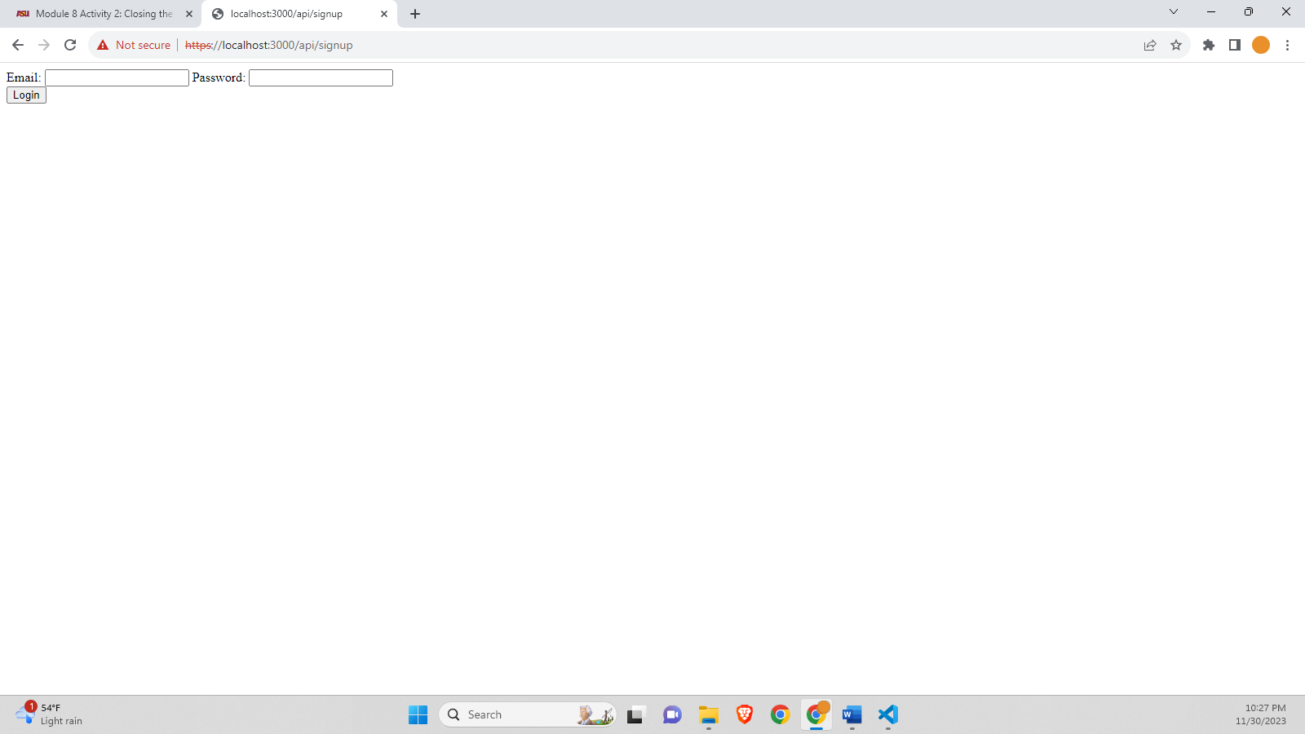

After clicking proceed to localhost we will get to login page but saying the site is not secure in address bar.

**Certification not valid-**

After clicking the Not secure text we can see the warning in detail and saying certificate is not valid.

**Protocol not working for http-**

If we enter http site the page is not working.